THE YALTA CONFERENCE – ACTIVITY 2
What happened behind the scenes?
The war against Hitler had united Roosevelt, Stalin and Churchill and at the Yalta Conference they appeared to get on well. The Source below illustrates the ‘public’ face of Yalta:

“I want to drink to our alliance, that it should not lose its ... intimacy, its free expression of views ... I know of no such close alliance of three Great Powers as this ... May it be strong and stable, may we be as frank as possible.”
- Stalin, proposing a toast at a dinner at the Yalta Conference, 1945

But what was going on behind the scenes?

Instructions:
- Read the sources on the TCIS History website.
- Once you have completed going through the sources, complete the table and diagram (see below) in the file titled "YALTA CONFERENCE - ACTIVITY 2.docx".
- Feel free to add and use ANY resources possible, but DO NOT COPY AND PASTE.
- Feel free to use the table and adjust the size of each box according to the amount of information you have provided.
- Read the marks scheme underneath the illustrated table below in order to understand how the activity will be graded.

Evidence of disagreement: | Evidence of agreement: | Reasons why the source is reliable or unreliable:
Ex. Describe how Source 2 (for example) reflects the disagreement/tension between the leaders mentioned. | Ex. Describe how Source 2 (for example) reflects the agreement/cordiality between the leaders mentioned.
N. B.: Not all sources will display both disagreements and agreements.
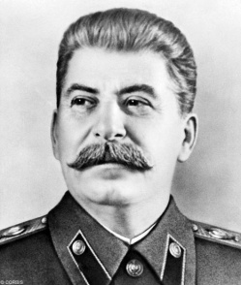
Using the diagram below and your knowledge at this point in time, summarize what each of the leaders thought of one another.

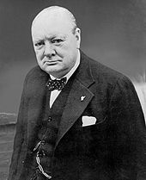
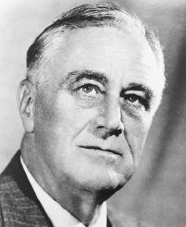

Mark Scheme
A | B | C | D | F
- Excellent – the summary of each disagreement & agreement found in the sources provided was discussed completely.  - The table clearly illustrates the growing differences and tensions between the two and greatly alludes to the continuing growth of mutual suspicion and fear between the “Big Three”.  - Well analyzed! | - You have discussed the disagreements and agreements found in the sources provided that occurred in the Yalta Conference very well.  - The table explains the growing differences and tensions between the parties involved and allude to the continuing growth of mutual suspicion and fear between the “Big Three”.  - Adequately analyzed. | - You have provided a decent amount of explanations in your discussion about the disagreement and agreements found in the Yalta Conference.  - The table provides a general overview of the growing differences and tensions between the “Big Three” and begins to illustrate the continuing growth of the mutual suspicion and fear between the “Big Three”. | - You have done a decent attempt in explaining the disagreements and agreements found in the sources during the Yalta Conference.  - The table briefly shows a simple overview of the growing differences and tensions between the “Big Three” and attempts to illustrate the continuing growth of mutual suspicion and fear between the “Big Three”. | - Little or no attempt has been done in this activity.

