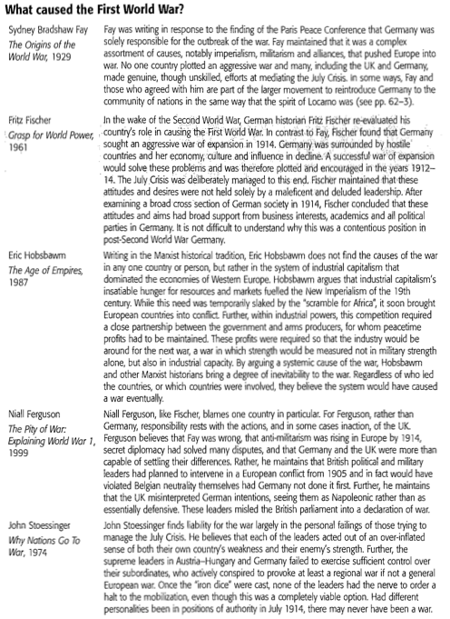

Source: Cannon, Martin, Jones-Nerzic, Richard, Keys, David, et. al. 20th Century World History Course Companion. Oxford: Oxford University Press, 2009.

